SAFETY DATA SHEET
OSHA HCS (29 CFR 1910.1200)

SECTION 1: PRODUCT AND COMPANY IDENTIFICATION
Product identifier
 | Chemical Name | Mixture
 | CAS No. | Mixture
 | Trade Name | ZYNSONIC ZYN-0201, 0203, 0204, 0205, 0209, 0210, 0212, 0214 AIR FRESHENERS
 | Product Code
Relevant identified uses of the substance or mixture and uses advised against
 | Identified Use(s) | Air Freshener
 | Uses Advised Against | None
 | Company Identification | Apex International Group, Inc.  P.O. Box 14607  North Palm Beach, FL 33408
 | Telephone | (561) 656-0850
 | Fax | (561) 656-0870
 | E-Mail (competent person) | apex@apexig.com
Emergency telephone number
 | Emergency Phone No. | Transportation Emergency: CHEMTREC 24 hr. 1-800-424-9300 / 1 (703) 527-3887 (Collect calls accepted)

SECTION 2: HAZARDS IDENTIFICATION
Classification of the substance or mixture
OSHA HCS (29 CFR 1910.1200) | Flam. Aerosol 1; Liquefied gas; STOT SE 3; Skin Irrit. 2; Eye Irrit. 2
Label elements
Hazard Symbol | 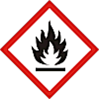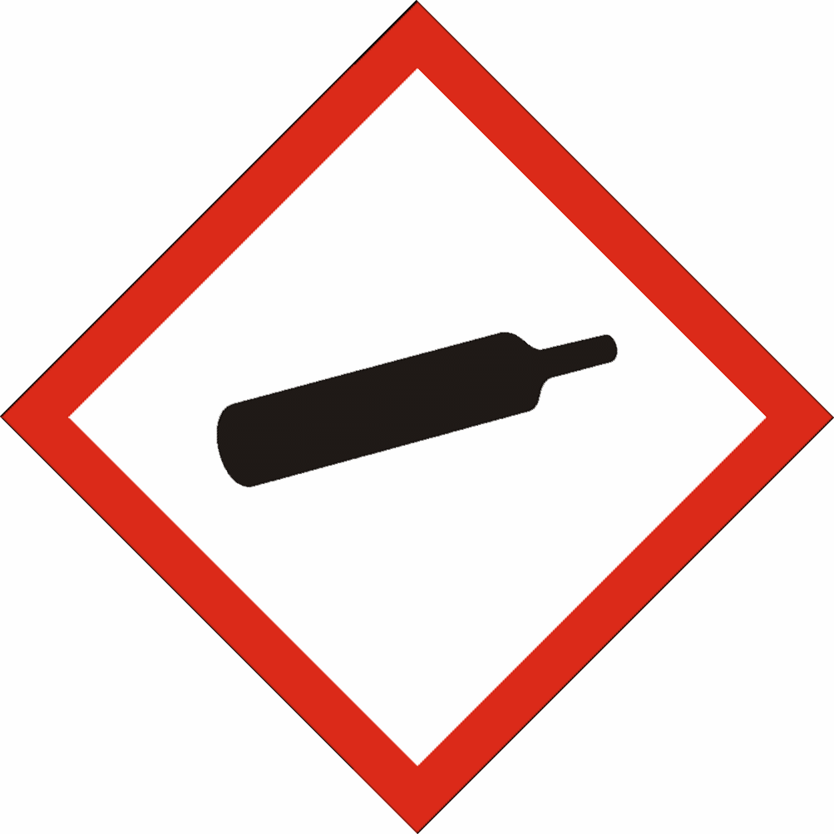
Signal word(s) | DANGER
Hazard Statement(s) | Extremely Flammable aerosol.  Contains gas under pressure; may explode if heated.  May cause drowsiness or dizziness.  Causes serious eye irritation.  Repeated exposure may cause skin dryness or cracking.
Precautionary Statement(s) | Keep away from heat/sparks/open flames/hot surfaces. – No smoking.  Do not spray on an open flame or other ignition source.  Do not pierce or burn, even after use.  Protect from sunlight and do not expose to temperatures exceeding 50 ºC/122 ºF.  Do not get in eyes. Avoid contact with skin.
Other hazards: | None
Additional Information: | None

SECTION 3: COMPOSITION/INFORMATION ON INGREDIENTS
Hazardous Ingredient(s) | % wt. * | CAS No. | Hazard classification
Acetone | > 70 | 67-64-1 | Flam. Liq. 2; H225  Eye Irrit. 2; H319  STOT SE 3; H336
Propane | 10 - 15 | 74-98-6 | Flam. Gas 1, H220  Press. Gas (*)
Butane | 10 - 15 | 106-97-8 | Flam. Gas 1, H220  Press. Gas (*)
Ordenone | < 1 | Proprietary | Eye Irrit. 2; H319  Skin Irrit. 2; H315.
Cinnamon | 0 – 3.5 | Proprietary | Eye Irrit. 2; H319  Skin Irrit. 2; H315.
Cucumber Melon | 0 – 3.5 | Proprietary | Eye Irrit. 2; H319  Skin Irrit. 2; H315.
Fresh Linen | 0 – 3.5 | Proprietary | Eye Irrit. 2; H319  Skin Irrit. 2; H315.
Orange | 0 – 3.5 | Proprietary | Eye Irrit. 2; H319  Skin Irrit. 2; H315.
Peach | 0 – 3.5 | Proprietary | Eye Irrit. 2; H319  Skin Irrit. 2; H315.
Vanilla | 0 – 3.5 | Proprietary | Eye Irrit. 2; H319  Skin Irrit. 2; H315.
Baby Powder | 0 – 3.5 | Proprietary | Eye Irrit. 2; H319  Skin Irrit. 2; H315.
Fabulous Lav | 0 – 3.5 | Proprietary | Eye Irrit. 2; H319  Skin Irrit. 2; H315.

Additional Information - None
* The exact percentage withheld as a trade secret in accordance with 29 CFR 1910.1200.

SECTION 4: FIRST AID MEASURES

Description of first aid measures
 | Inhalation |  | Not normally required. Move person to fresh air. If breathing is labored, administer oxygen. If symptoms develop, obtain medical attention.
 | Skin Contact |  | Not normally required. Wash affected skin with soap and water. If symptoms develop, obtain medical attention.
 | Eye Contact |  | Rinse cautiously with water for several minutes. Remove contact lenses, if present and easy to do. Continue rinsing. If eye irritation persists, get medical advice/attention.
 | Ingestion |  | Unlikely to be required but if necessary treat symptomatically.
Most important symptoms and effects, both acute and delayed |  |  | Irritating to eyes.
Indication of any immediate medical attention and special treatment needed |  |  | None

SECTION 5: FIRE-FIGHTING MEASURES
Extinguishing Media
-Suitable Extinguishing Media |  | Extinguish with carbon dioxide, dry chemical, foam or water spray.
-Unsuitable Extinguishing Media |  | Do not use water jet.
Special hazards arising from the substance or mixture |  | Highly flammable vapor (flash point below 23°C).
Advice for fire-fighters |  | A self contained breathing apparatus and suitable protective clothing should be worn in fire conditions. Keep containers cool by spraying with water if exposed to fire.

SECTION 6: ACCIDENTAL RELEASE MEASURES
Personal precautions, protective equipment and emergency procedures | Keep away from heat/sparks/open flames/hot surfaces. – No smoking. Avoid contact with skin and eyes. Avoid breathing vapors.
Environmental precautions | Prevent liquid entering sewers, basements and work pits.
Methods and material for containment and cleaning up | Cover spills with inert absorbent material. Transfer to a container for disposal or recovery.
Reference to other sections | None
Additional Information | None

SECTION 7: HANDLING AND STORAGE
Precautions for safe handling | Keep away from heat/sparks/open flames/hot surfaces. – No smoking. Avoid contact with skin and eyes. Avoid breathing vapors.
Conditions for safe storage, including any incompatibilities
-Storage temperature | Keep in a cool, well ventilated place. Store at temperatures not exceeding 50 °C / 122 °F.
-Incompatible materials | This product should be stored away from sources of strong heat or oxidizing chemicals.
Specific end use(s) | Air Freshener

SECTION 8: EXPOSURE CONTROLS/PERSONAL PROTECTION
Occupational Exposure Limits
SUBSTANCE. | CAS No. | (8hr TWA) |  | (STEL) |  | Note:
SUBSTANCE. | CAS No. | PEL  (OSHA) | TLV (ACGIH) | PEL  (OSHA) | TLV (ACGIH) | Note:
Acetone | 67-64-1 | 1000 | 500 | ------ | 750 | ^NIC
n-Butane | 106-97-8 | ----- | 250 ppm | ----- | ----- | -----
Propane | 74-98-6 | 1000 ppm | Aspyx.# | ----- | ----- | #
^NIC = Notice of Intended Changes (ACGIH®)
Recommended monitoring method |  | NIOSH 1300 (Ketones I); NIOSH 1500 (hydrocarbons, B.P. 36 - 126 ºC) ; NIOSH 1501 (Hydrocarbons, Aromatic)
Exposure controls
Appropriate engineering controls |  |  |  | Provide adequate ventilation to ensure that the occupational exposure limit is not exceeded.
Personal protection equipment
 | Eye/face protection   |  |  | Not normally required. Do not get in eyes.
 | Skin protection (Hand protection/ Other)   |  |  | Wear suitable gloves if prolonged skin contact is likely. Check with protective equipment manufacturer's data.
 | Respiratory protection   |  |  | Normally no personal respiratory protection is necessary.
 | Thermal hazards |  |  | Not normally required.
Environmental Exposure Controls |  |  |  | None known

SECTION 9: PHYSICAL AND CHEMICAL PROPERTIES
Information on basic physical and chemical properties
Appearance | Liquid / Aerosol
Color. | Clear
Odor | Not available
Odor Threshold (ppm) | Not available
pH (Value) | Not available
Melting Point (°C) / Freezing Point (°C) | Not available
Boiling point/boiling range (°C): | 56 (Acetone)
Flash Point (°C) | -17 (Acetone)
Evaporation Rate | Not available
Flammability (solid, gas) | Extremely flammable aerosol.
Explosive Limit Ranges | 2.1% - 9.5% v/v (Propane)
Vapor pressure (Pascal) | ca. 95 x 10⁴ (Propane)
Vapor Density (Air=1) | ca. 1.56 @ 0ºC (Propane)
Density (g/ml) | Not available
Solubility (Water) | Not available
Solubility (Other) | Not available
Partition Coefficient (n-Octanol/water) | Not available
Auto Ignition Point (°C) | 450 (Propane)
Decomposition Temperature (°C) | Not available
Kinematic Viscosity (cSt) | < 20.5 @ 40 0ºC
Explosive properties | Not explosive.
Oxidizing properties | Not oxidizing.
Other information | Not available

SECTION 10: STABILITY AND REACTIVITY
Reactivity | Stable under normal conditions.
Chemical stability | Stable.
Possibility of hazardous reactions | None anticipated.
Conditions to avoid | Avoid contact with heat and ignition sources.
Incompatible materials | Strong oxidizing agents
Hazardous decomposition product(s) | Carbon monoxide, Carbon dioxide, Acrid smoke

SECTION 11: TOXICOLOGICAL INFORMATION
Exposure routes: Inhalation, Skin Contact, Eye Contact
Information on toxicological effects
Acetone (CAS No. 67-64-1)
Acute toxicity | Oral LD50 = 5800 mg/kg (rat)  Dermal LD50 >15800 mg/kg (rabbit)  Inhalation LC50 76 mg/L (4 hour(s)) (rat) - Vapours may cause drowsiness and dizziness.
Irritation / Corrosivity | Causes serious eye irritation. Repeated exposure may cause skin dryness or cracking.
Sensitisation | It is not a skin sensitiser.
Repeated dose toxicity | Oral NOAEL = 900 mg/kg/day (rat) (90-days)  Inhalation NOAEL > 19,000 ppm (rat)
Carcinogenicity | It is unlikely to present a carcinogenic hazard to man.
NTP | IARC | ACGIH | OSHA | NIOSH
No. | No. | No. | No. | No.

Mutagenicity | Negative
Toxicity for reproduction | Negative
Other information | None known.
Propane (CAS# 74-98-6):
Acute toxicity | Inhalation: LC50 = 1237 mg/L (2-hr, mouse, gas)
Irritation/Corrosivity | No evidence of irritant effects from normal handling and use.
Sensitisation | It is not a skin sensitiser.
Repeated dose toxicity | NOAEC: >19678 mg/m3 (28-day, rat, Systemic effects)  LOAEC: 21641 mg/m3 (28-day, rat, effects: Body weight)
Carcinogenicity | No data. It is unlikely to present a carcinogenic hazard to man.
Mutagenicity | There is no evidence of mutagenic potential.
Reproductive toxicity | None anticipated

SECTION 12: ECOLOGICAL INFORMATION
Ecotoxicity
Short term (estimated / calculated) | LC50 (96 hour): >100 mg/L (fish)  LC50 (48 hour): >100 mg/L (crustacea)  LC50 (72 hour): >100 mg/L (algae)
Long Term | No data
Persistence and degradability | Readily biodegradable.
Bioaccumulative potential | The product has no potential for bioaccumulation.
Mobility in soil | Not available
Results of PBT and vPvB assessment | Not classified as PBT or vPvB.
Other adverse effects | None known.

SECTION 13: DISPOSAL CONSIDERATIONS
Waste treatment methods | Disposal should be in accordance with local, state or national legislation. Consult an accredited waste disposal contractor or the local authority for advice.

SECTION 14: TRANSPORT INFORMATION
 | U.S. DOT | Sea transport  (IMDG) | Air transport (ICAO/IATA)
UN number | 1950 | 1950 | 1950
Proper Shipping Name | Aerosols, flammable | Aerosols, flammable | Aerosols, flammable
Transport hazard class(es) | 2.1 | 2.1 | 2.1
Packing group | Not applicable | Not applicable | Not applicable
Environmental hazards | None assigned | None assigned | None assigned
Special precautions for user | None assigned | None assigned | None assigned
Transport in bulk according to Annex II of MARPOL73/78 and the IBC Code: Not applicable

SECTION 15: REGULATORY INFORMATION
Safety, health and environmental regulations/legislation specific for the substance or mixture:
TSCA (Toxic Substance Control Act) - Inventory Status: All components listed or polymer exempt.
Designated Hazardous Substances and Reportable Quantities (40 CFR 302.4):
 |  |  | Chemical Name | CAS No. |  |  | Typical %wt. |  |  |  | RQ (Pounds)
 |  |  | Acetone | 67-64-1 |  |  | 40 - 50 |  |  |  | 5000
SARA 311/312 - Hazard Categories:
 | Fire Sudden Release Reactivity Immediate (acute) Chronic (delayed)
SARA 313 - Toxic Chemicals (40 CFR 372):
 |  |  | Chemical Name |  |  |  |  | CAS No. |  |  |  |  | Typical %wt.
 |  |  | None |  |  |  |  | ---- |  |  |  |  | -------
SARA 302 - Extremely Hazardous Substances(40 CFR 355):
 |  |  | Chemical Name |  |  | CAS No. |  |  |  | Typical %wt. |  | TPQ (pounds)
 |  |  | None |  |  | ---- |  |  |  | ---- |  | ----
California Proposition 65 List:
 |  | Chemical Name |  |  | CAS No. |  |  |  | Type of Toxicity
 |  | None |  |  | ----- |  |  |  | ------------

SECTION 16: OTHER INFORMATION
The following sections contain revisions or new statements: 1-16.
Date of preparation: August 28, 2015
Hazard Statement(s) and Risk Phrases Listed in: SECTION 2:/ SECTION 3:
Hazard Statement(s)
- H220: Extremely flammable gas.
- H225: Highly flammable liquid and vapor.
- H315: Causes skin irritation.
- H319: Causes serious eye irritation.
- H336: May cause drowsiness or dizziness.

Training advice: None.
Disclaimer: We believe the statements, technical information and recommendations contained herein are reliable, but they are given without warranty or guarantee of any kind. The information contained in this document applies to this specific material as supplied. It may not be valid for this material if it is used in combination with any other materials. It is the user’s responsibility to satisfy oneself as to the suitability and completeness of this information for the user’s own particular use.

