SAFETY DATA SHEET
OSHA HCS (29 CFR 1910.1200)

SECTION 1: PRODUCT AND COMPANY IDENTIFICATION
Product identifier
 | Chemical Name | Mixture
 | CAS No. | Mixture
 | Trade Name | APEX ZYNSONIC STAINLESS STEEL CLEANER
 | Stock No.: | Zyn-0002 CODE: 803.01
Relevant identified uses of the substance or mixture and uses advised against
 | Identified Use(s) | Stainless Steel Cleaner
 | Uses Advised Against | None
 | Company Identification | Apex International Group, Inc.  P.O. Box 14607  North Palm Beach, FL 33408
 | Telephone | (561) 656-0850
 | Fax | (561) 656-0870
 | E-Mail (competent person) | apex@apexig.com
Emergency telephone number
 | Emergency Phone No. | Transportation Emergency: CHEMTREC 24 hr. 1-800-424-9300 / 1 (703) 527-3887 (Collect calls accepted)

SECTION 2: HAZARDS IDENTIFICATION
Classification of the substance or mixture
 | OSHA HCS (29 CFR 1910.1200) | Flam. Aerosol 1; Liquefied gas; Skin Irrit. 2; Eye Irrit. 2; STOT SE 3; Asp. Tox. 1
Label elements
 | Hazard Symbol | 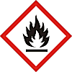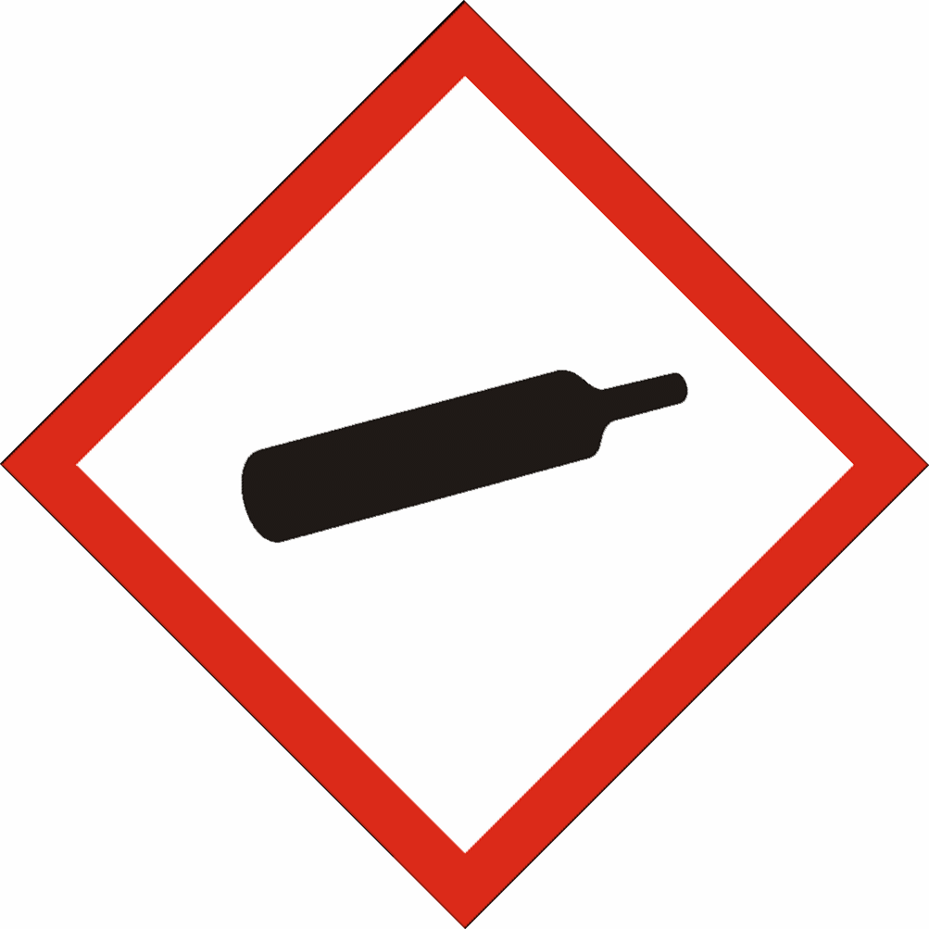
 | Signal word(s) | DANGER
 | Hazard Statement(s) | Extremely flammable aerosol.  Contains gas under pressure; may explode if heated.  Causes skin irritation.  Causes serious eye irritation.  May be fatal if swallowed and enters airways.  May cause drowsiness or dizziness.
 | Precautionary Statement(s) | Keep away from heat/sparks/open flames/hot surfaces. – No smoking.  Do not spray on an open flame or other ignition source.  Pressurized container: Do not pierce or burn, even after use.  Wear protective gloves/eye protection/face protection.  Use only outdoors or in a well-ventilated area.  Avoid breathing spray.  Wash hands and exposed skin after use.  Protect from sunlight and do not expose to temperatures exceeding 50 ºC/122 ºF.
Other hazards |  | Toxic to aquatic life. Toxic to aquatic life with long lasting effects.

SECTION 3: COMPOSITION/INFORMATION ON INGREDIENTS
Hazardous Ingredient(s) | % wt. * | CAS No. | Hazard classification
Petroleum distillate | 80 - 90 | Trade Secret | Flam. Liq. 3; H226  Skin Irrit. 2; H315  Asp. Tox. 1; H304  STOT SE 3; H336  Aquatic Acute 2; H401  Aquatic Chronic 2; H411
Acetone | 10 - 20 | 67-64-1 | Flam. Liq. 2; H225  Eye Irrit. 2; H319  STOT SE 3; H336
Propane | 10 - 20 | 74-98-6 | Flam. Gas 1; H220  Liquefied gas; H280

Additional Information - None
* The exact percentage withheld as a trade secret in accordance with 29 CFR 1910.1200.

SECTION 4: FIRST AID MEASURES

Description of first aid measures
 | Inhalation |  | Move person to fresh air. If breathing is labored, administer oxygen. If symptoms develop, obtain medical attention.
 | Skin Contact |  | Wash affected skin with soap and water. If skin irritation occurs, get medical advice/attention. Take off contaminated clothing and wash it before reuse.
 | Eye Contact |  | Rinse cautiously with water for several minutes. Remove contact lenses, if present and easy to do. Continue rinsing. If eye irritation persists: Get medical advice/attention.
 | Ingestion |  | Do not give anything by mouth to an unconscious person. Do NOT induce vomiting. Get immediate medical attention.
Most important symptoms and effects, both acute and delayed |  |  | Aspiration of droplets may cause pulmonary oedema. May cause drowsiness and dizziness.
Indication of any immediate medical attention and special treatment needed |  |  | IF SWALLOWED: Immediately call a POISON CENTER or doctor/physician.

SECTION 5: FIRE-FIGHTING MEASURES
Extinguishing Media
-Suitable Extinguishing Media |  | Extinguish with carbon dioxide, dry chemical, foam or water spray.
-Unsuitable Extinguishing Media |  | Do not use water jet.
Special hazards arising from the substance or mixture |  | Highly flammable vapor (flash point below 23°C).
Advice for fire-fighters |  | A self contained breathing apparatus and suitable protective clothing should be worn in fire conditions. Keep containers cool by spraying with water if exposed to fire.

SECTION 6: ACCIDENTAL RELEASE MEASURES
Personal precautions, protective equipment and emergency procedures | Eliminate sources of ignition. Wear protective gloves/eye protection/face protection. Avoid contact with skin and eyes. Avoid breathing spray.
Environmental precautions | Prevent liquid entering sewers, basements and work pits. Avoid release to the environment. Collect spillage.
Methods and material for containment and cleaning up | Cover spills with inert absorbent material. Transfer to a container for disposal or recovery.
Reference to other sections | None
Additional Information | None

SECTION 7: HANDLING AND STORAGE
Precautions for safe handling | Keep away from heat/sparks/open flames/hot surfaces. – No smoking. Take precautionary measures against static discharge. Avoid contact with skin and eyes. Use product in a well-ventilated area only. Avoid breathing spray.
Conditions for safe storage, including any incompatibilities
-Storage temperature | Keep in a cool, well ventilated place. Keep container tightly closed. Store at temperatures not exceeding 50 °C / 122 °F. Protect from sunlight.
-Incompatible materials | This product should be stored away from sources of strong heat or oxidizing chemicals. Avoid contact with: chlorine, fluorine, and other strong oxidizers.
Specific end use(s) | Stainless Steel Cleaner

SECTION 8: EXPOSURE CONTROLS/PERSONAL PROTECTION
Occupational Exposure Limits
SUBSTANCE. | CAS No. | (8hr TWA) |  | (STEL) |  | Note:
SUBSTANCE. | CAS No. | PEL  (OSHA) | TLV (ACGIH) | PEL  (OSHA) | TLV (ACGIH) | Note:
Heptane, branched, cylic and linear | 426260-76-6 | 500 ppm* | 1500 mg/m³ | ----- | ----- | *n-heptane
Alkanes and cycloalkanes, C5 - C8 | ----- | ----- | 1500 mg/m3 | ----- | ----- | -----
Alkanes & Cycloalkanes, C9-C15 | ----- | ----- | 1200 mg/m3 | ----- | ----- | -----
White Mineral Oil | 8042-47-5 | 5 mg/m3 | 5 mg/m3^{(I)} | ----- | ----- | ^{(I)}Inhalable
Acetone | 67-64-1 | 1000 ppm | 500 ppm | ------ | 750 ppm | ^NIC
Propane | 74-98-6 | 1000 ppm | Aspyx.# | ----- | ----- | #
^NIC = Notice of Intended Changes (ACGIH®); #Assure minimum oxygen content of work atmosphere.
Recommended monitoring method |  | NIOSH 1300 (Ketones I); NIOSH 1500 (hydrocarbons, B.P. 36 - 126 ºC); NIOSH 1550 (Naphthas); NIOSH 5026 (Oil mist; mineral)
Exposure controls
Appropriate engineering controls |  |  |  | Provide adequate ventilation to ensure that the occupational exposure limit is not exceeded.
Personal protection equipment
 | Eye/face protection   |  |  | Wear protective eyewear (goggles, face shield, or safety glasses).
 | Skin protection (Hand protection/ Other)   |  |  | Wear suitable gloves if prolonged skin contact is likely (Butyl rubber)
 | Respiratory protection   |  |  | Normally no personal respiratory protection is necessary. In case of insufficient ventilation, wear suitable respiratory equipment. Check with protective equipment manufacturer's data.
 | Thermal hazards |  |  | Not normally required. Use gloves with insulation for thermal protection, when needed.
Environmental Exposure Controls |  |  |  | Avoid release to the environment.

SECTION 9: PHYSICAL AND CHEMICAL PROPERTIES
Information on basic physical and chemical properties
Appearance | Aerosol spray
Color. | Colorless
Odor | Hydrocarbon
Odor Threshold (ppm) | Not available
pH (Value) | Not available
Melting Point (°C) / Freezing Point (°C) | Not available
Boiling point/boiling range (°C): | Not available
Flash Point (°C) | -104 (Propane)
Evaporation Rate | Not available
Flammability (solid, gas) | Extremely flammable
Explosive Limit Ranges | 2.1% - 9.5% v/v (Propane)
Vapor pressure (Pascal) | ca. 95 x 10⁴ (Propane)
Vapor Density (Air=1) | ca. 1.56 @ 0ºC (Propane)
Density (g/ml) | Not available
Solubility (Water) | Not available
Solubility (Other) | Not available
Partition Coefficient (n-Octanol/water) | Not available
Auto Ignition Point (°C) | 450 (Propane)
Decomposition Temperature (°C) | Not available
Kinematic Viscosity | 1.92 cSt @ 40°C (Distillates (petroleum), hydrotreated light)
Explosive properties | Not explosive.
Oxidizing properties | Not oxidizing.
Other information | Not available

SECTION 10: STABILITY AND REACTIVITY
Reactivity | Stable under normal conditions.
Chemical stability | Stable.
Possibility of hazardous reactions | None anticipated.
Conditions to avoid | Avoid contact with heat and ignition sources.
Incompatible materials | This product should be stored away from sources of strong heat or oxidizing chemicals. Avoid contact with: chlorine, fluorine, and other strong oxidizers.
Hazardous decomposition product(s) | Carbon monoxide, Carbon dioxide, and Acrid smoke.

SECTION 11: TOXICOLOGICAL INFORMATION
Exposure routes: Inhalation, Skin Contact, Eye Contact

Substances in preparations / mixtures
Heptane, branched, cylic and linear (CAS# 426260-76-6) - By analogy with similar materials:
Acute toxicity |  | Oral: LD50 >5 g/kg-bw  Dermal: LD50 >2 g/kg-bw  Inhalation: LC50 = 65 - 103 mg/L (Vapor), 4-hr. rat  May cause drowsiness or dizziness.  May be fatal if swallowed and enters airways.
Irritation/Corrosivity |  | Causes skin irritation. Repeated exposure may cause skin dryness or cracking. May cause eye irritation.
Sensitization |  | It is not a skin sensitizer.
Repeated dose toxicity |  | NOAEC: 12350 mg/m3 (2 yr, inhal., rat, Systemic effects)  LOAEC: 1650 mg/m3 (2 hr, inhal., rat, CNS effects)  May cause drowsiness or dizziness.
Carcinogenicity |  | No data. It is unlikely to present a carcinogenic hazard to man.
NTP | IARC | ACGIH | OSHA | NIOSH
No. | No. | No. | No. | No.

Mutagenicity |  | There is no evidence of mutagenic potential.
Reproductive toxicity |  | Not available
Acetone (CAS No. 67-64-1)
Acute toxicity | Oral LD50 = 5800 mg/kg (rat)  Dermal LD50 >15800 mg/kg (rabbit)  Inhalation LC50 76 mg/L (4 hour(s)) (rat) - Vapours may cause drowsiness and dizziness.
Irritation / Corrosivity | Causes serious eye irritation. Repeated exposure may cause skin dryness or cracking.
Sensitisation | It is not a skin sensitiser.
Repeated dose toxicity | Oral NOAEL = 900 mg/kg/day (rat) (90-days)  Inhalation NOAEL > 19,000 ppm (rat)
Carcinogenicity | It is unlikely to present a carcinogenic hazard to man.
NTP | IARC | ACGIH | OSHA | NIOSH
No. | No. | No. | No. | No.

Mutagenicity | Negative
Toxicity for reproduction | Negative
Other information | None known.
Hydrotreated Light Distillate (CAS No. 64742-47-8) - By analogy with similar materials:
Acute toxicity |  | Oral: LD50 >5 g/kg-bw  Dermal: LD50 >2 g/kg-bw  Inhalation: LC50 >20 mg/l (Vapor), 4-hr. rat - May cause drowsiness or dizziness.  May be fatal if swallowed and enters airways.
Irritation/Corrosivity |  | Causes skin irritation. Repeated exposure may cause skin dryness or cracking.
Sensitization |  | It is not a skin sensitizer.
Repeated dose toxicity |  | No data
Carcinogenicity |  | It is unlikely to present a carcinogenic hazard to man.
NTP | IARC | ACGIH | OSHA | NIOSH
No. | No. | No. | No. | No.

Mutagenicity |  | Not to be expected
Reproductive toxicity |  | Not to be expected

SECTION 12: ECOLOGICAL INFORMATION
Toxicity - Substances in preparations / mixtures
Heptane, branched, cylic and linear (CAS# 426260-76-6) - By analogy with similar materials:
Short term | LL50 (96 hour): >13.4 mg/L (Oncorhynchus mykiss)  EL50 (48 hour): 3 mg/l (Daphnia magna, mobility)  EC50 (96 hour): 13 mg/l (Pseudokirchnerella subcapitata)
Long Term | NOELR (28 days) 1.5 mg/l (Fish) QSAR  LOEC (21 days): 0.32 mg/l (Daphnia magna)  NOEL (96 hour) 6.3 mg/l (Algae)
Hydrotreated Light Distillate (CAS No. 64742-47-8) - By analogy with similar materials:
Short term |  | LC50 (96 hour): 2.5 mg/L (fish)  EC50 (48 hour): 1.4 mg/L (crustacea)  EC50 (72 hour): 1.3 mg/L (algae)
Long Term |  | NOEC (28 days): 0.098 mg/L (fish)  LOEC (21 days): 1.2 mg/L (crustacea)  LOEL (72 hour): 1 mg/L (algae)
Persistence and degradability |  | Biodegradable
Bioaccumulative potential |  | The product has no potential for bioaccumulation.
Mobility in soil |  | Not available.
Results of PBT and vPvB assessment |  | Not classified as PBT or vPvB.
Other adverse effects |  | None known.

SECTION 13: DISPOSAL CONSIDERATIONS
Waste treatment methods | Disposal should be in accordance with local, state or national legislation. Consult an accredited waste disposal contractor or the local authority for advice.

SECTION 14: TRANSPORT INFORMATION
 | U.S. DOT | Sea transport  (IMDG) | Air transport (ICAO/IATA)
UN number | 1950 | 1950 | 1950
Proper Shipping Name | Aerosols, flammable | Aerosols, flammable | Aerosols, flammable
Transport hazard class(es) | 2.1 | 2.1 | 2.1
Packing group | Not applicable | Not applicable | Not applicable
Environmental hazards | None assigned | None assigned | None assigned
Special precautions for user | None assigned | None assigned | None assigned
Transport in bulk according to Annex II of MARPOL73/78 and the IBC Code: Not applicable

SECTION 15: REGULATORY INFORMATION
Safety, health and environmental regulations/legislation specific for the substance or mixture:
TSCA (Toxic Substance Control Act) - Inventory Status: All components listed or polymer exempt.
Designated Hazardous Substances and Reportable Quantities (40 CFR 302.4):
 |  |  | Chemical Name | CAS No. |  |  | Typical %wt. |  |  |  | RQ (Pounds)
 |  |  | Acetone | 67-64-1 |  |  | 15 |  |  |  | 5000
SARA 311/312 - Hazard Categories:
 | Fire Sudden Release Reactivity Immediate (acute) Chronic (delayed)
SARA 313 - Toxic Chemicals (40 CFR 372):
 |  |  | Chemical Name |  |  |  |  | CAS No. |  |  |  |  | Typical %wt.
 |  |  | None |  |  |  |  | ---- |  |  |  |  | ----
SARA 302 - Extremely Hazardous Substances(40 CFR 355):
 |  |  | Chemical Name |  |  | CAS No. |  |  |  | Typical %wt. |  | TPQ (pounds)
 |  |  | None |  |  | ---- |  |  |  | ---- |  | ----
California Proposition 65 List:
 |  | Chemical Name |  |  | CAS No. |  |  |  | Type of Toxicity
 |  | None |  |  | ---- |  |  |  | ----

SECTION 16: OTHER INFORMATION
The following sections contain revisions or new statements: 1-16.
Date of preparation: May 12, 2015
Hazard Statement(s) and Risk Phrases Listed in: SECTION 2:/ SECTION 3:
Hazard Statement(s)
- H220: Extremely flammable gas.
- H225: Highly flammable liquid and vapor.
- H226: Flammable liquid and vapour.
- H227: Combustible liquid.
- H280: Contains gas under pressure; may explode if heated.
- H304: May be fatal if swallowed and enters airways.
- H315: Causes skin irritation.
- H319: Causes serious eye irritation.
- H336: May cause drowsiness or dizziness.
- H401: Toxic to aquatic life.
- H411: Toxic to aquatic life with long lasting effects.
- H412: Harmful to aquatic life with long lasting effects.
Training advice: None.
Disclaimer: We believe the statements, technical information and recommendations contained herein are reliable, but they are given without warranty or guarantee of any kind. The information contained in this document applies to this specific material as supplied. It may not be valid for this material if it is used in combination with any other materials. It is the user’s responsibility to satisfy oneself as to the suitability and completeness of this information for the user’s own particular use.

