SAFETY DATA SHEET
OSHA HCS (29 CFR 1910.1200)

SECTION 1: PRODUCT AND COMPANY IDENTIFICATION
Product identifier
 | Chemical Name | Mixture
 | CAS No. | Mixture
 | Trade Name | ZYNSONIC FURNITURE POLISH
 | Product Code | Stock #: ZYN-0008
Relevant identified uses of the substance or mixture and uses advised against
 | Identified Use(s) | Furniture polish
 | Uses Advised Against | None
 | Company Identification | Apex International Group, Inc.  P.O. Box 14607  North Palm Beach, FL 33408
 | Telephone | (561) 656-0850
 | Fax | (561) 656-0870
 | E-Mail (competent person) | apex@apexig.com
Emergency telephone number
 | Emergency Phone No. | Transportation Emergency: CHEMTREC 24 hr. 1-800-424-9300 / 1 (703) 527-3887 (Collect calls accepted)

SECTION 2: HAZARDS IDENTIFICATION
Classification of the substance or mixture
 | OSHA HCS (29 CFR 1910.1200) | Flam. Aerosol 2; Liquefied gas; Skin Irrit. 2; STOT SE 3; Asp. Tox. 1
Label elements
 | Hazard Symbol | 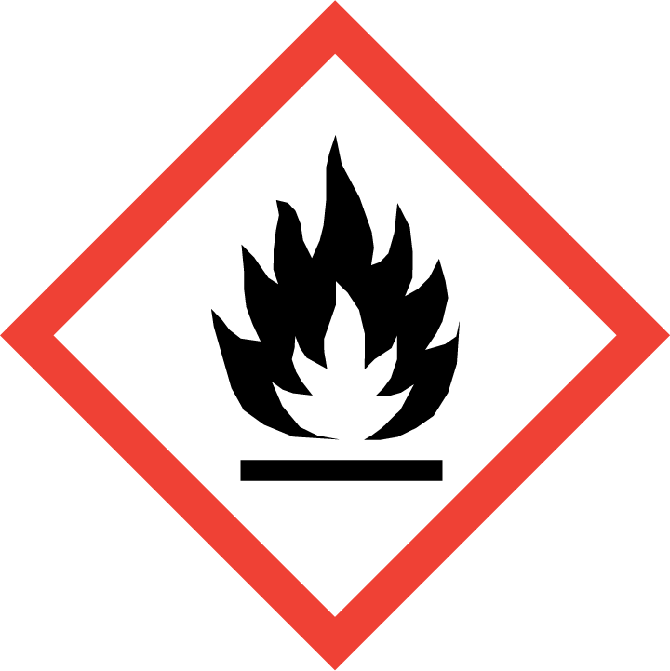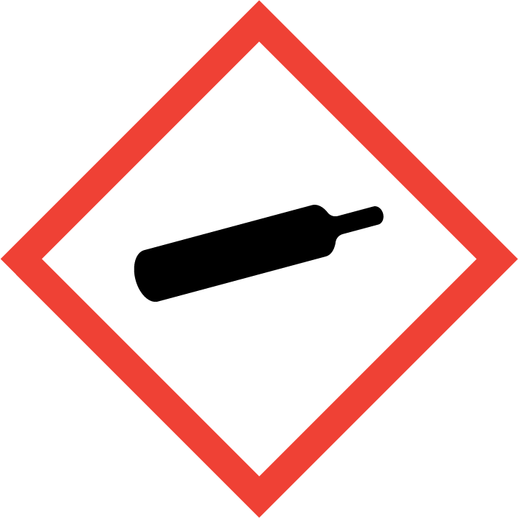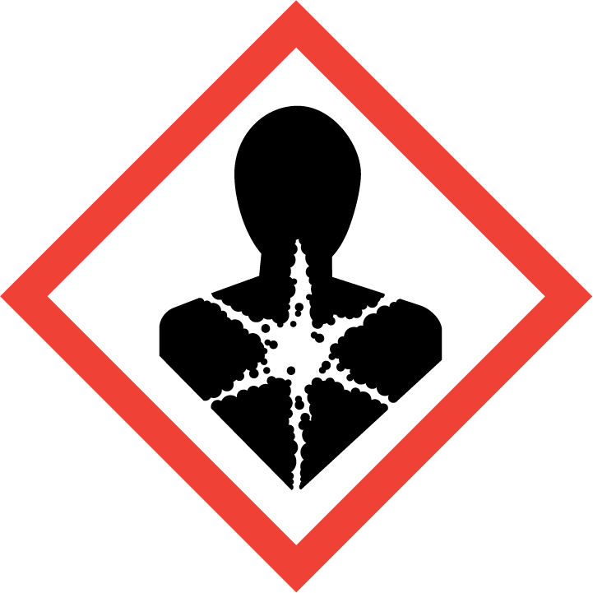
 | Signal word(s) | DANGER
 | Hazard Statement(s) | Flammable aerosol.  Contains gas under pressure; may explode if heated.  May be fatal if swallowed and enters airways.  Causes skin irritation.  May cause drowsiness or dizziness.
 | Precautionary Statement(s) | Keep away from heat, hot surfaces, sparks, open flames and other ignition sources. No smoking.  Do not spray on an open flame or other ignition source.  Do not pierce or burn, even after use.  Wash hands and exposed skin after use.  Wear protective gloves/protective clothing/eye protection/face protection.  Avoid breathing dust/fume/gas/mist/vapours/spray.  Protect from sunlight and do not expose to temperatures exceeding 50 ºC/122 ºF.
Other hazards |  | Harmful to aquatic life. Harmful to aquatic life with long lasting effects.

SECTION 3: COMPOSITION/INFORMATION ON INGREDIENTS
Hazardous Ingredient(s) | % wt. * | CAS No. | Hazard classification
Distillates (petroleum), hydrotreated light | > 5 | 64742-47-8 | Flam. Liq. 4; H227  Skin Irrit. 2; H315  Asp. Tox. 1; H304  STOT SE 3; H336  Aquatic Acute 2; H401  Aquatic Chronic 2; H411
Propane | 1 - 10 | 74-98-6 | Flam. Gas 1; H220  Liquefied gas; H280
n-Butane | 1 - 10 | 106-97-8 | Flam. Gas 1; H220  Liquefied gas; H280

Additional Information - None
* The exact percentage withheld as a trade secret in accordance with 29 CFR 1910.1200.

SECTION 4: FIRST AID MEASURES

Description of first aid measures
 | Inhalation |  | Move person to fresh air. If breathing is labored, administer oxygen. If symptoms develop, obtain medical attention.
 | Skin Contact |  | Wash affected skin with soap and water. If symptoms develop, obtain medical attention.
 | Eye Contact |  | Rinse cautiously with water for several minutes. Remove contact lenses, if present and easy to do. Continue rinsing. If eye irritation persists, get medical advice/attention.
 | Ingestion |  | Do not give anything by mouth to an unconscious person. Seek medical treatment. Do NOT induce vomiting.
Most important symptoms and effects, both acute and delayed |  |  | May be harmful if swallowed and enters airways.
Indication of any immediate medical attention and special treatment needed |  |  | IF SWALLOWED: Immediately call a POISON CENTER or doctor/physician. Do NOT induce vomiting.

SECTION 5: FIRE-FIGHTING MEASURES
Extinguishing Media
-Suitable Extinguishing Media |  | Extinguish with carbon dioxide, dry chemical, foam or water spray.
-Unsuitable Extinguishing Media |  | Do not use water jet.
Special hazards arising from the substance or mixture |  | None
Advice for fire-fighters |  | A self contained breathing apparatus and suitable protective clothing should be worn in fire conditions. Keep containers cool by spraying with water if exposed to fire.

SECTION 6: ACCIDENTAL RELEASE MEASURES
Personal precautions, protective equipment and emergency procedures | Keep away from heat/sparks/open flames/hot surfaces. – No smoking. Avoid contact with skin and eyes. Avoid breathing gas/spray.
Environmental precautions | Prevent liquid entering sewers, basements and work pits.
Methods and material for containment and cleaning up | Cover spills with inert absorbent material. Transfer to a container for disposal or recovery.
Reference to other sections | None
Additional Information | None

SECTION 7: HANDLING AND STORAGE
Precautions for safe handling | Keep away from heat/sparks/open flames/hot surfaces. – No smoking. Avoid contact with skin and eyes. Use product in a well-ventilated area only. Avoid breathing gas/spray.
Conditions for safe storage, including any incompatibilities
-Storage temperature | Keep in a cool, well ventilated place. Protect from sunlight and do not expose to temperatures exceeding 50 ºC/122 ºF.
-Incompatible materials | This product should be stored away from sources of strong heat or oxidizing chemicals.
Specific end use(s) | Furniture polish

SECTION 8: EXPOSURE CONTROLS/PERSONAL PROTECTION
Occupational Exposure Limits
SUBSTANCE. | CAS No. | (8hr TWA) |  | (STEL) |  | Note:
SUBSTANCE. | CAS No. | PEL  (OSHA) | TLV (ACGIH) | PEL  (OSHA) | TLV (ACGIH) | Note:
Propane | 74-98-6 | 1000 ppm | Aspyx.# | ------- | ------- | #
n-Butane | 106-97-8 | 600 ppm | 250 ppm | 750 ppm | ------- | -------
Alkanes (C9-C15) | ------- | ------- | 1200 mg/m3 | ------- | ------- | -------
^NIC = Notice of Intended Changes (ACGIH®); #Assure minimum oxygen content
Recommended monitoring method |  |  | NIOSH 1500 (hydrocarbons, B.P. 36 - 126 ºC)
Exposure controls
Appropriate engineering controls |  | Provide adequate ventilation to ensure that the occupational exposure limit is not exceeded.
Personal protection equipment
 | Eye/face protection   |  |  |  | Wear protective eyewear (goggles, face shield, or safety glasses).
 | Skin protection (Hand protection/ Other)   |  |  |  | Wear suitable gloves if prolonged skin contact is likely (Butyl rubber). Check with protective equipment manufacturer's data.
 | Respiratory protection   |  |  |  | Normally no personal respiratory protection is necessary. In case of insufficient ventilation, wear suitable respiratory equipment. Check with protective equipment manufacturer's data.
 | Thermal hazards |  |  |  | Not normally required. Use gloves with insulation for thermal protection, when needed.
Environmental Exposure Controls |  |  |  |  | Avoid release to the environment.

SECTION 9: PHYSICAL AND CHEMICAL PROPERTIES
Information on basic physical and chemical properties
Appearance | Aerosol spray
Color. | Not available
Odor | Not available
Odor Threshold (ppm) | Not available
pH (Value) | Not available
Melting Point (°C) / Freezing Point (°C) | Not available
Boiling point/boiling range (°C): | Not available
Flash Point (°C) | -104 (Propane)
Evaporation Rate | Not available
Flammability (solid, gas) | Flammable aerosol
Explosive Limit Ranges | 2.1% - 9.5% v/v (Propane)
Vapor pressure (Pascal) | ca. 95 x 10⁴ (Propane)
Vapor Density (Air=1) | ca. 1.56 @ 0 ºC (Propane)
Density (g/ml) | Not available
Solubility (Water) | Not available
Solubility (Other) | Not available
Partition Coefficient (n-Octanol/water) | Not available
Auto Ignition Point (°C) | Not available
Decomposition Temperature (°C) | Not available
Kinematic Viscosity (cSt) | <20.5 @ 40 °C
Explosive properties | Not explosive.
Oxidizing properties | Not oxidizing.
Other information | Not available

SECTION 10: STABILITY AND REACTIVITY
Reactivity | Stable under normal conditions.
Chemical stability | Stable.
Possibility of hazardous reactions | None anticipated.
Conditions to avoid | Avoid contact with heat and ignition sources.
Incompatible materials | Strong oxidizing agents
Hazardous decomposition product(s) | Carbon monoxide, Carbon dioxide, Acrid smoke

SECTION 11: TOXICOLOGICAL INFORMATION
Exposure routes: Skin Contact, Eye Contact
Substances in preparations / mixtures
Distillates (petroleum), hydrotreated light (CAS# 64742-47-8):
Acute toxicity | Oral: LD50 >55 g/kg-bw  Dermal: LD50 >3 g/kg-bw
Irritation/Corrosivity | Repeated exposure may cause skin dryness or cracking.
Sensitisation | It is not a skin sensitizer.
Repeated dose toxicity | No information available
Carcinogenicity | No data. It is unlikely to present a carcinogenic hazard to man.
NTP | IARC | ACGIH | OSHA | NIOSH
No. | No. | No. | No. | No.

Mutagenicity | There is no evidence of mutagenic potential.
Reproductive toxicity | No information available
Propane (CAS# 74-98-6):
Acute toxicity | Inhalation: LC50 = 1237 mg/L (2-hr, mouse, gas)
Irritation/Corrosivity | No evidence of irritant effects from normal handling and use.
Sensitisation | It is not a skin sensitiser.
Repeated dose toxicity | NOAEC: >19678 mg/m3 (28-day, rat, Systemic effects)  LOAEC: 21641 mg/m3 (28-day, rat, effects: Body weight)
Carcinogenicity | No data. It is unlikely to present a carcinogenic hazard to man.
NTP | IARC | ACGIH | OSHA | NIOSH
No. | No. | No. | No. | No.

Mutagenicity | There is no evidence of mutagenic potential.
Reproductive toxicity | None anticipated

SECTION 12: ECOLOGICAL INFORMATION

Ecotoxicity
Hydrotreated Light Distillate (CAS No. 64742-47-8) - By analogy with similar materials:
Short term | LC50 (96 hour): 2.5 mg/L (fish)  EC50 (48 hour): 1.4 mg/L (crustacea)  EC50 (72 hour): 1.3 mg/L (algae)
Long Term | NOEC (28 days): 0.098 mg/L (fish)  LOEC (21 days): 1.2 mg/L (crustacea)  LOEL (72 hour): 1 mg/L (algae)
Propane (CAS# 74-98-6):
Short term (estimate) | LC50 (96 hour): 27.98 mg/L (fish)  LC50 (48 hour): 14.22 mg/L (crustacea)  EC50 (96 hour): 7.71 mg/L (algae)
Long Term | No data.
Persistence and degradability | Readily biodegradable.
Bioaccumulative potential | The product has no potential for bioaccumulation.
Mobility in soil | Not available.
Results of PBT and vPvB assessment | Not classified as PBT or vPvB.
Other adverse effects | None known.

SECTION 13: DISPOSAL CONSIDERATIONS
Waste treatment methods | Disposal should be in accordance with local, state or national legislation. Consult an accredited waste disposal contractor or the local authority for advice.

SECTION 14: TRANSPORT INFORMATION
 | U.S. DOT | Sea transport  (IMDG) | Air transport (ICAO/IATA)
UN number | 1950 | 1950 | 1950
Proper Shipping Name | Aerosols, flammable | Aerosols, flammable | Aerosols, flammable
Transport hazard class(es) | 2.1 | 2.1 | 2.1
Packing group | Not applicable | Not applicable | Not applicable
Environmental hazards | None assigned | None assigned | None assigned
Special precautions for user | None assigned | None assigned | None assigned
Transport in bulk according to Annex II of MARPOL73/78 and the IBC Code: Not applicable

SECTION 15: REGULATORY INFORMATION
Safety, health and environmental regulations/legislation specific for the substance or mixture:
TSCA (Toxic Substance Control Act) - Inventory Status: All components listed or polymer exempt.
Designated Hazardous Substances and Reportable Quantities (40 CFR 302.4):
 |  |  | Chemical Name | CAS No. |  | Typical %wt. |  |  | RQ (Pounds)
 |  |  | None | ------ |  | ------
SARA 311/312 - Hazard Categories:
 | Fire Sudden Release Reactivity Immediate (acute) Chronic (delayed)
SARA 313 - Toxic Chemicals (40 CFR 372):
 |  |  | Chemical Name |  |  |  | CAS No. |  |  |  | Typical %wt.
 |  |  | None |  |  |  | ---- |  |  |  | ----
SARA 302 - Extremely Hazardous Substances(40 CFR 355):
 |  |  | Chemical Name |  | CAS No. |  |  | Typical %wt. |  | TPQ (pounds)
 |  |  | None |  | ---- |  |  | ---- |  | ----
California Proposition 65 List:
 |  | Chemical Name |  |  | CAS No. |  | Type of Toxicity
 |  | None |  |  | ---- |  | ----

SECTION 16: OTHER INFORMATION
The following sections contain revisions or new statements: 1-16.
Date of preparation: April 4, 2015
Hazard Statement(s) and Risk Phrases Listed in: SECTION 2:/ SECTION 3:
Hazard Statement(s)
- H220: Extremely flammable gas.
- H227: Combustible liquid.
- H280: Contains gas under pressure; may explode if heated.
- H304: May be fatal if swallowed and enters airways.
- H315: Causes skin irritation.
- H319: Causes serious eye irritation.
- H336: May cause drowsiness or dizziness.
- H401: Toxic to aquatic life.
- H411: Toxic to aquatic life with long lasting effects.
Training advice: None.
Disclaimer: We believe the statements, technical information and recommendations contained herein are reliable, but they are given without warranty or guarantee of any kind. The information contained in this document applies to this specific material as supplied. It may not be valid for this material if it is used in combination with any other materials. It is the user’s responsibility to satisfy oneself as to the suitability and completeness of this information for the user’s own particular use.

